{Date}
{Resident Name}
{Address}
Laboratory Results for PFAS Water Sample Collected from Your Residence at {Address}
Dear {Resident Name},
Thank you for participating in the private well-water sampling project. Your contribution is vital in helping us better understand the presence and behavior of PFAS (per- and polyfluoroalkyl substances) in groundwater. After collection, your water sample was tested by the Wisconsin State Laboratory of Hygiene (WSLH).
PFAS are a group of synthetic chemicals that are persistent in the environment and resistant to breakdown. Long-term exposure to certain PFAS at elevated levels may be linked to various health concerns, which is why monitoring their levels in private well water is so important.
What We Found in Your Water:
Your water sample was analyzed for 40 different PFAS compounds. There were no PFAS detected in your water. Please refer to the attached laboratory results for full details.

Information about PFAS:
For general information about PFAS, please visit the resources below.

Resource Type | Organization | Website | QR Code
Reading Your PFAS Lab Results | University of Wisconsin Madison – Extension | https://naturalresources.extension.wisc.edu/files/2022/01/English_How-to-read-your-results-guide_PFAS_Final.pdf | 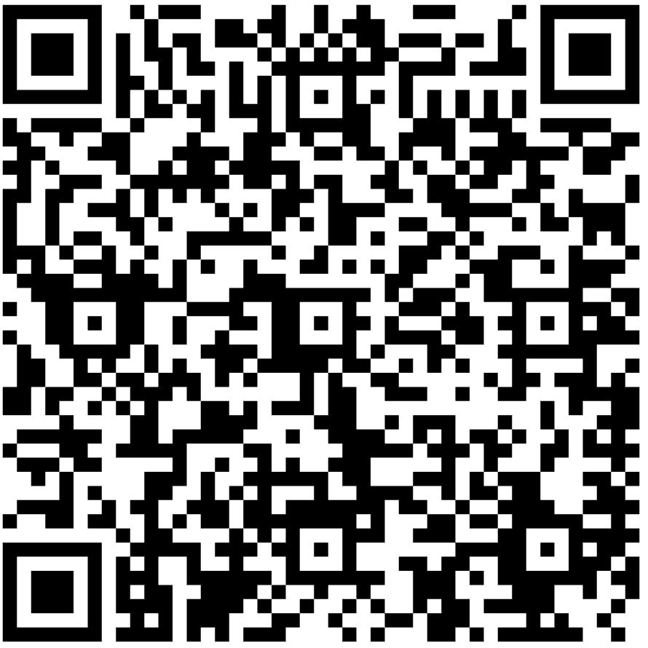
PFAS in Well Water | Wisconsin Department of Health Services | https://www.dhs.wisconsin.gov/publications/p03212.pdf | 
Health Impacts | Wisconsin Department of Health Services | https://www.dhs.wisconsin.gov/chemical/pfas.htm | 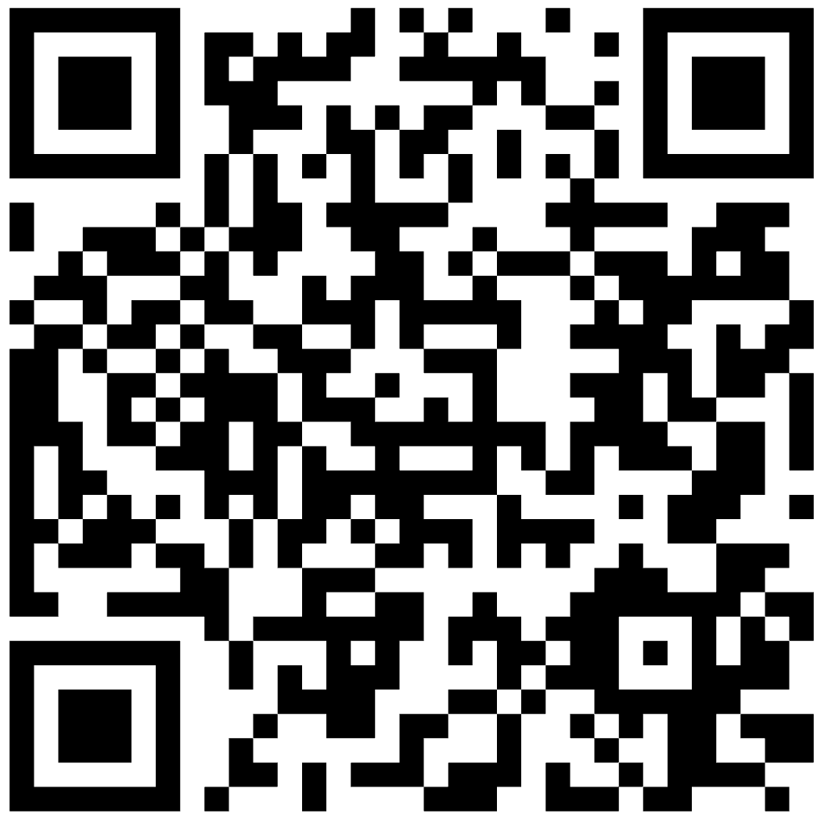
Environmental Impacts | Wisconsin Department of Natural Resources | https://dnr.wisconsin.gov/topic/PFAS/Impacts.html | 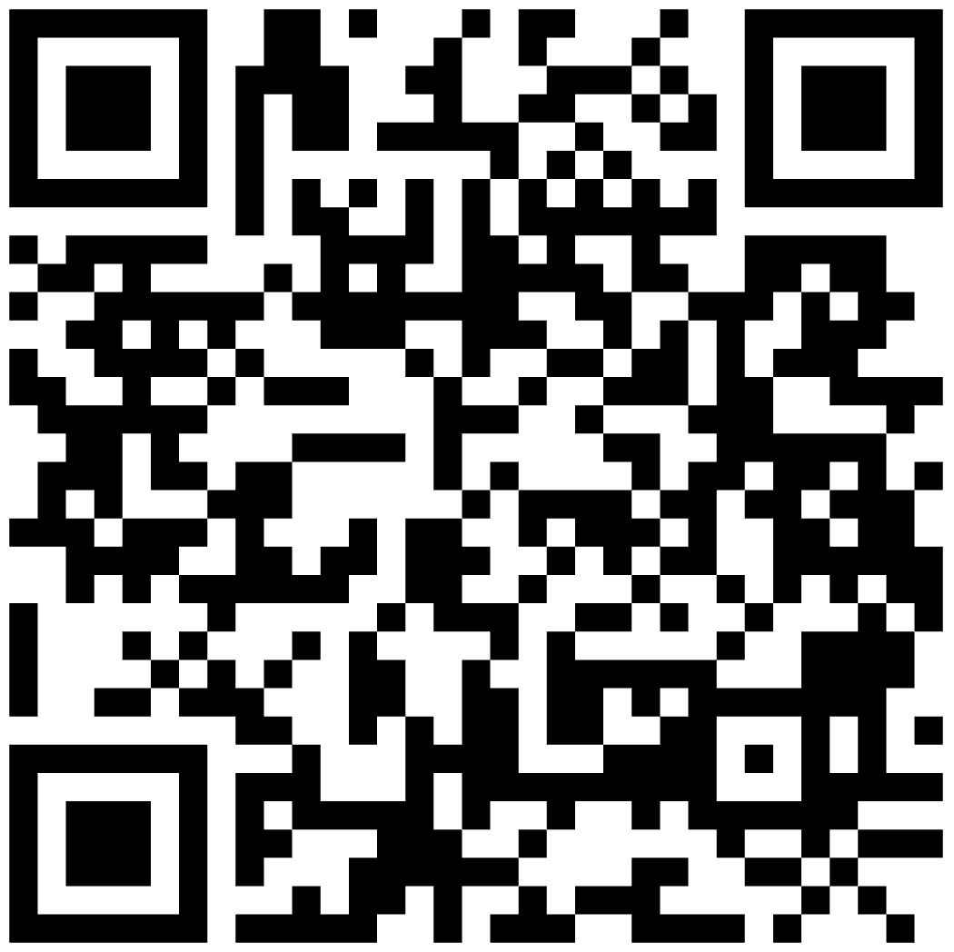

Contacts:
If you have any questions or need assistance interpreting your results, please see the contact information below.

Well-Related Questions
{Water Supply Specialist Name}
{Contact information}
Water Supply Specialist
Wisconsin Department of Natural Resources

Health Related Questions
For health-related questions specific to an individual, please contact your doctor.
Wisconsin Department of Health Services – Environmental Health  dhsenvhealth@wi.gov  (608) 266-1120 | {Health Contact Name}  {Contact information}  {Position/Title}  {Organization}

PFAS Related Questions
Wisconsin Department of Natural Resources – PFAS Questions
DNRPFASInquiries@wisconsin.gov

PFAS Testing Questions
{Laboratory Name}
{Contact information}

